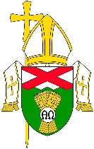
RIGHT to BE SAFE
RIGHT to FEEL SAFE

Every child, young person and adult at risk
in our Parish community
has the right to be safe and to feel safe
from abuse of any form.

Our Diocesan Safeguarding Policy is clear:
We commit ourselves to ensure
the safety and well-being of children, young people and adults at risk
in our community.
The best interests of the child, young person or adult at risk
come first.
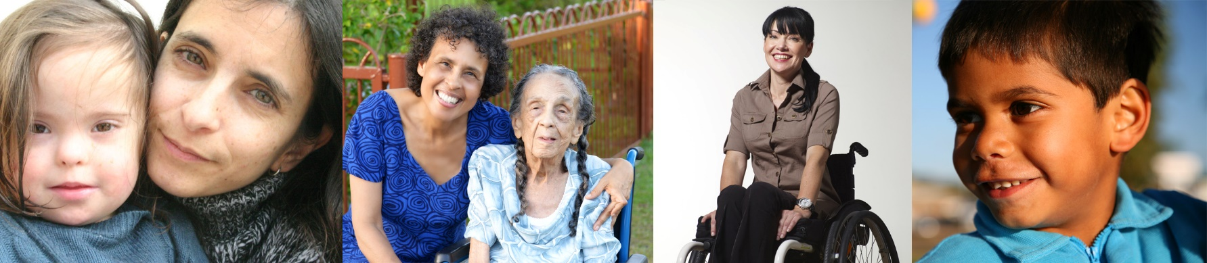

If you are concerned about a child, young person or adult at risk
YOU CAN MAKE CONTACT WITH and TALK TO

OUR PARISH SAFEGUARDING CONTACT: | OUR DIOCESAN SAFEGUARDING MINISTRY OFFICE:  Fr Peter Dorfield  07 4638 1379  0408 459 045  profstandards@twb.catholic.org.au

Diocesan Safeguarding Ministry: 15 January 2021

