Spiritual Enrichment Day:
“Invited into a Dialogue of Faith, Love and New Life”

Facilitator: Sr. Elaine Morzone MFIC
Venue: SYCHAR, 69 Margaret Street, Toowoomba
Date: Thursday 5 December 2019
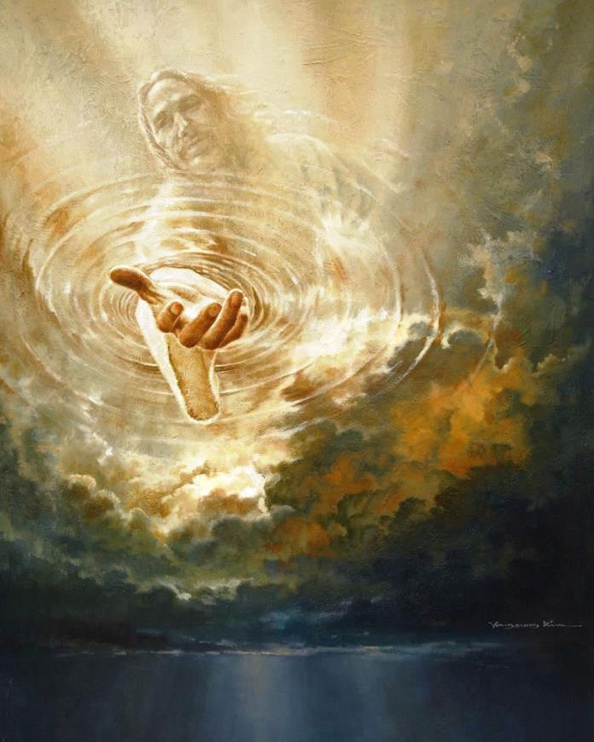

Calling- Yongsung Kim

Wakan (HolyMary Southard, C.S.J.
9.30 am – 10.30 am Session One
Through the Lens of Love
          - One Thing Lacking
          - One Thing Necessary

10.30 am -11.00am Morning Tea Break

11.00 am – 12.00 pm Session Two
A Touch that Brings Healing,
A Gaze that Makes Whole

12.00 pm – 12.45 pm Lunch

12.45 pm – 2. 00 pm Session Three
If Only…!

No cost involved – Please bring a a plate to share.

