Spiritual Enrichment Day:
“Invited into a Dialogue of Faith, Love and New Life”

Facilitator: Sr. Elaine Morzone MFIC
Venue: Jandowae Date: Sunday 13 October 2019
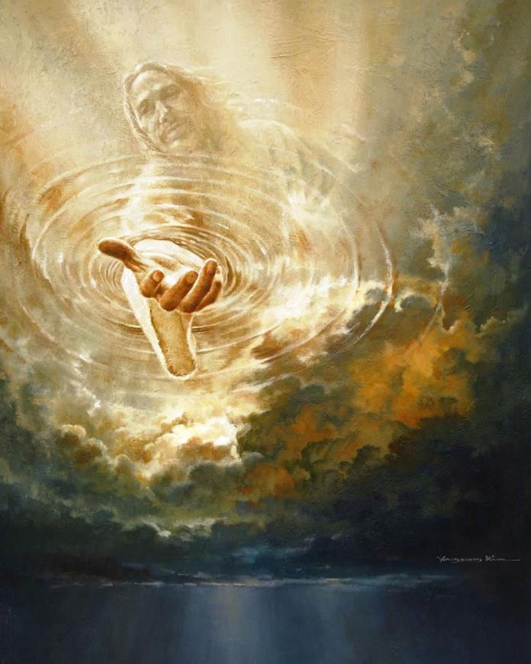

Calling- Yongsung Kim

Time Schedule: Flexible, beginning once we are ready after Liturgy.

Session Themes:
Session One
Wakan (HolyMary Southard, C.S.J.
Through the Lens of Love
          - One Thing Lacking
          - One Thing Necessary

Session Two
A Touch that Brings Healing,
A Gaze that Makes Whole

Session Three
If Only…!

